**SecurityTrails: Domain and IP intelligence**.



**Introduction**

Security trials are simulated exercises designed to test the robustness of an organization's security posture against various cyber threats. These trials help identify vulnerabilities, assess incident response capabilities, and evaluate the effectiveness of security controls. This challenge focuses on conducting security trials to enhance readiness and resilience against potential cyberattacks.

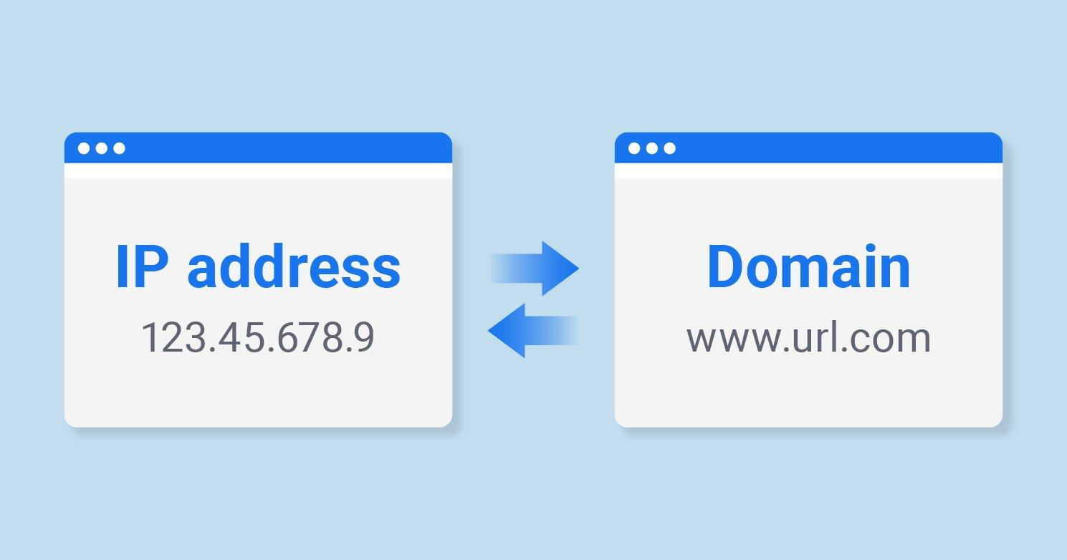

**Scenario**

As part of your role in the cybersecurity team, you are conducting security trials to assess the organization's preparedness against cyber threats. Using SecurityTrails, you will gather domain and IP intelligence to identify potential vulnerabilities, verify domain information, and understand the infrastructure of targeted domains. This exercise will help enhance your understanding of domain and IP analysis, which is crucial for strengthening security measures.

**Process to Perform**

**Step 1:** You can click on this link <https://securitytrails.com/> or open any web browser in your pc and search for security trials.

**Step 02:** Enter the Targeted Domain named as **facebook.com**

**Step 03:** Capture the Flag

**Question**

Flag 1: What is the IP address of the facebook.com

Answer: 157.240.229.35

Flag Captured.

What is SOA records of Facebook.com

Ans: dns.facebook.com

Flag Captured

How many ns records are there?

Ans: 4

Flag Captured

Hint

